1. How many signals does I2C protocol use to send and receive data between devices? What are these signals and describe their functionality? (5 pts)
   1. The I2C protocol consists of two signals SDA and SCL. A Serial Data signal to transfer data. The other being a Serial Clock that is used a clock signal.
2. How do you start and end serial communication with I2C protocol? Be specific about the timing relationship between Serial Data Line (SDA) and Serial Clock Line (SCLK) signal. Draw the necessary timing diagrams to clarify your point. (5 pts)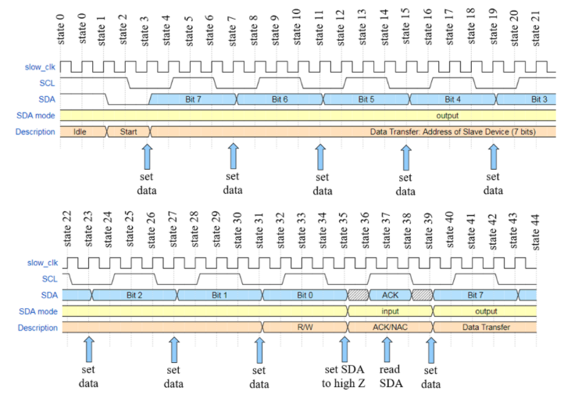
   1. To start there is the idle state where both SDA and SCL are held logic high. Initializing the start condition is done by bringing the SDA low. Then data is sent throughout the clock signals. The stop condition is initiated when the SDA line goes from low to high while the SCL is high. After that the bus will return to the idle state it started in.
3. What is the maximum frequency for the SCL signal? You should check for this information in the temperature sensor data sheet as it is device specific. (5 pts)
   1. 400kHZ
4. After how many transfer bits from the master to the slave device, does the slave device sends back an acknowledgment? (5 pts)
   1. 8-bits
5. How many bits is the default temperature output? (5 pts)
   1. 13-bits
   2. The address is chosen using pins A0 and A1 and there are four possible options for you to send it too.